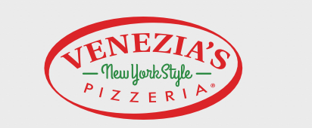
1tray Barbeque and 1 tray buffalo= $120

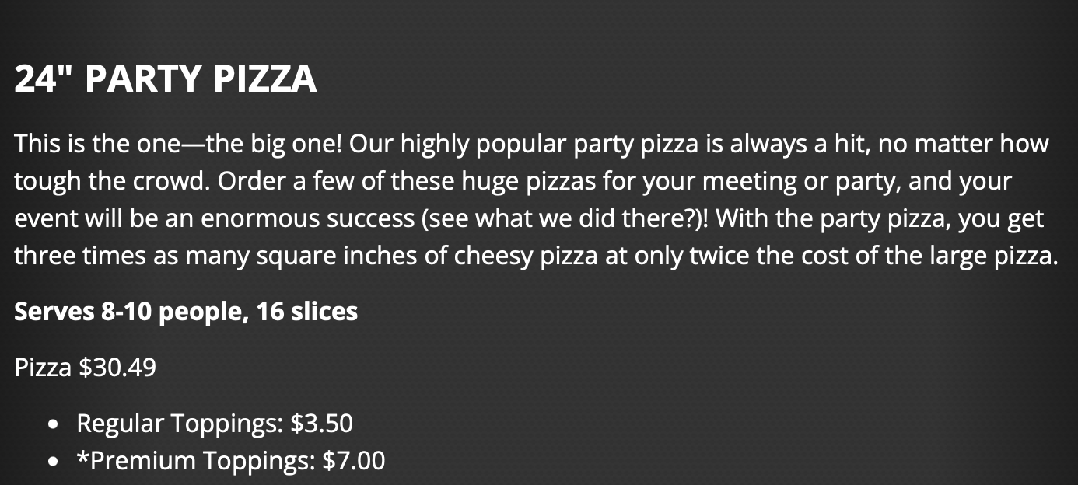
7 Trays of the party pizza(3 cheese, 2 pepperoni, 2 meat treat)= $241

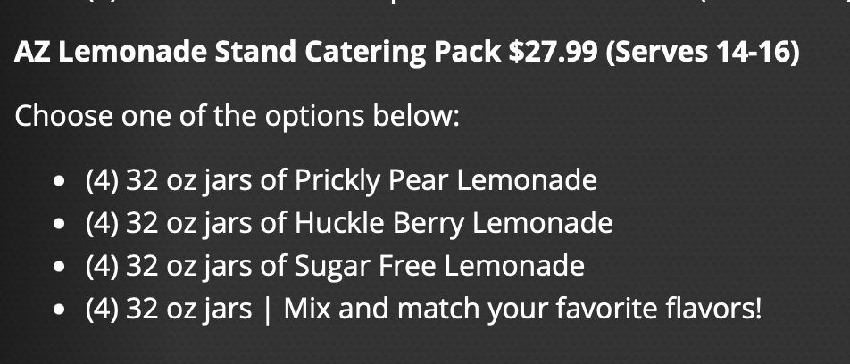
1 prickly pear lemonade and 1 huckleberry (lemonade stand catering pack) = $56

Total: 417 + tax == estimate $450

